**Acknowledgement**

We obtain this opportunity to showcase our skills towards the given project named “**Matrial Sharing**” under taken during 6th semester of Bachelor of Computer Application. We offer our sincere thanks to **SmtV.B.Nandola Computer Science College Bhacha** for giving us the opportunity to work in their organization and making all the resources available for us throughout the development of the project as well as providing excellent facilities.

We wish to express our sincere thanks to **Mr. PankajZalera** , the principal of B.C.A for his selfless support and guidance. His valuable suggestion guidance and knowledge have contributed a lot in the successful of the project.

We would also like to thanks every staff member of the college for giving us opportunity to complete our project successfully. We are very thankful to Ms. KunjanJesingani. They have Constantly encouraged and appreciate us and their positive criticism has been vital at all stage of development and improvement in the project and very thankful to our staff member like internal guide Mr.HirenSelani ,Ms.KunjanJesingani, for providing us true guidance and support without it we may not able to complete this project . Thanks for your True Support.

***Yours Faithfully***

Vipul M. Kotval

**Institute Profile**

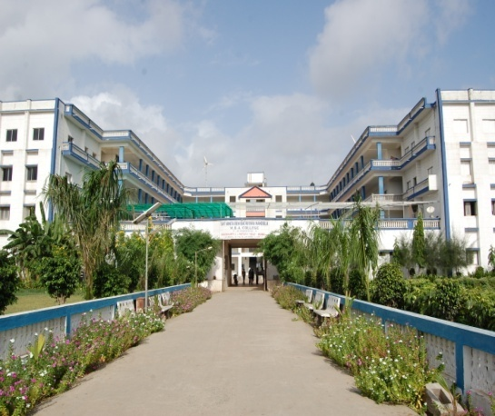

Smt.V.B.Nandola Computer Science college was establish in the year 2008 to take up the challenge of Effective education and training of professionals for careers in management and computer studies. The institute is approved by the Saurastra University. Now the B.M.Nandola trust become a landmark, the institute has become a constituent of it.

The institute has provided all the required infrastructure and excellent facilities to the student right from the inception.

The institute right from Commencement has been sincerely committed to the cause of profession education in the areas of and hence has spared no efforts to create an academic environment conducive for effective learning .The institute’s main attempt was to meet one of its cherished goals of providing the industry with a reservoir of managerial talent with a sound education foundation enhanced.

To the end, the institute has taken a concrete and positive initiative to mould the student’s attitudes towards their work, toward others and most importantly towards themselves. The institute being those which would distinguish them from the other help them to be humble, to be open to change yet be prudent enough to judge when and which change is for better.

**Student Profile**

|  |  |
| --- | --- |
| **Enrolment Number** | 30501600346 |
| **Student Name** | Kotval Vipul M. |
| **Date Of Birth** | 25/11/1996 |
| **Department** | BCA |
| **Semester** | 6 |
| **Email** | [vipulkotval07@gmail.com](mailto:vipulkotval07@gmail.com) |
| **Mobile Number** | 9723971161 |

|  |  |
| --- | --- |
| **Name** | **Description** |
| Project Title | Matrial Sharing |
| Organization Name | Smt.V.B.Nandola Computer Science College-Bhacha |
| Group Size | 1 One |
| Project Duration | 3 Month |
| Front End | ASP.Net (.Net Framework 4.5) |
| Back End | SQL Server 2012 |
| Document Tool | MS Word 2013 ,MS Power point 2013 |
| GUI Tool | Visual Studio 2013 |
| External Guide | [www.google.com](http://www.google.com)  [www.csharpcorner.com](http://www.csharpcorner.com)  [www.stackoverflow.com](http://www.stackoverflow.com) |
| Internal Guide | KunjanJesingani |
| Submitted To | Smt.V.B.Nandola Computer Science College-Bhacha |

**Project Profile**

**Project Definition**

**Matrial Sharing** is developed using Microsoft Visual ASP.Net front end tool and C# Back End tool. Weare studentsof B.C.A (SmtV.B.Nandola Computer Science College-Bhacha) made this project for “**Matrial Shareing**”.

It is very much important as a practical work of our study in Computer Education.

Material sharing is the practice of sharing or offering access to digital information or resources, including.Our project material hub (material sharing) is solution for those people who try to crack government exam any one can download latest study material by free of coast by just simply login in our site.

**Introduction about Project**

Every decade has its own development and its own story. From many years ago every moment development has come from lifecycle, item and many more. Today development become possible though information technology. Today it becomes an essential part of our life. With The help of computer we can do most of the all things without wasting our time, very faster and easier.

Computer can be useful to us by our requirement or any time consuming and tedious work of calculation. If we use computer properly and develop user needed software, it will relive from tedious work.

Looking to the important of computer and its utilization our university **BhanktKaviNarshinh Mehta University** has introduce various courses of computer science & application, BCA is one of them. In Sem-6 BCA student has to prepare project. It provides an occasion for to realize the important of resource and time management, ownership of task towards deliverable, innovation and efficiency in task management. It also provides an opportunity for build, in hence and sustains high level of professional conduct and performance and evolve a problem solve frame of mind in student.

**Introduction about Front End [ASP.Net]**

ASP.NET is a web application framework developed and marketed by Microsoft to allow programmers to build dynamic websites, web applications and web services.

ASP.NET gives you the ability to code in any supported .NET language (including Visual Basic, C#, J#, and many other languages that have third-party compilers).

It consists of a large number of controls such as text boxes, buttons, and labels for assembling, configuring, and manipulating code to create HTML pages.

**Features of ASP.Net**

1. Easy Programming Model
2. Flexible Language Options
3. Rich Class Framework
4. Easy deployment and dynamic update of running application
5. XML Web Services
6. Mobile web device support

**INTRODUCTION ABOUT BACK-END**

**SQL SERVER**

* SQL Stand for **Structure Query Language**.
* SQL is the language use to manipulate relational database.
* SQL is a programming standard originally developed in the 1970s that is now used in many database and related technology
* Retrieve data from a database
* Insert/update/delete record in a database
* Set permission
* SQL Server is relational database management system developed by Microsoft Corporation.
* SQL Server is the most widely used database is the word.
* SQL Provide statement for a variety of task including.
* Inserting, updating, deleting, database object.
* Creating, modifying and database object.
* Benefits of using SQL 2005
* Handled large amount of data efficiently.
* First in current infrastructure.

**Hardware Requirement**

|  |  |
| --- | --- |
| **Name** | **Description** |
| Hard Disk | 30 GB Free space |
| Processor | P4, dual core |
| Ram | 1 GB Minimum |
| Webcam | No |
| Scanner | No |
| Printer | No |

**Browser Requirement**

|  |  |
| --- | --- |
| **Name** | **Description** |
| Mozilla | XP,Windows 7, Window 8 , Windows 10 |
| Chrome | ASP.Net |
|  | C# |
| .NET Framework | .NET Framework 4.5 |

**System Development Life Cycle (SDLC)**

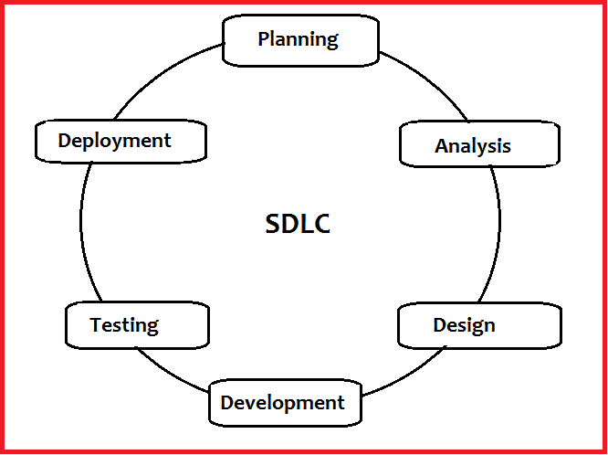

* System development life cycle means combination of various activities to develop and maintain systems.
* It helps in establishing a system project plan, because it gives overall list of processes and sub-processes required developing a system.

1. **Planning:-**

* It is the first stage of SDLC. In this stage plans are created and implemented.
* In this stage, scope and requirements of the system are identified.
* The Limitations and problems are also studied.

1. **Analysis:-**

* Analysis is a detailed study of the system and its various activities.
* Analysis means to collect data on the available files, decision points and transactions handled by the system.
* **Interviews, on-site observation and questionnaire** are the tools used for system analysis.

3. **Design :-**

* Based on the user requirements and the detailed analysis of new system, the new system must be designed.
* The design has two stages :
  1. **Preliminary / General Design :** In this design, features, cost and benefits of the system are specified.
  2. **Structure / Detailed Design :** In this design, computer oriented work begins.
* **Flowchart, Data Flow Diagram, Data Dictionary, Decision Table & Tree** is the tools used in designing.

1. **Coding :**

* After designing the new system, whole system is required to be converted into computer programming language.

**5. Testing:-**

* After coding all programs of the system, it is important to test the system.
* The purpose is to find errors within the system as well as verifying whether the system behaves as expected and according to the requirements.
* The system is tested again and again until all requirements are fulfilled and all defects have been fixed.

**6. Maintenance:**

* Once a version of the software is released to the management, there is usually a maintenance team that looks after any post – production issues.
* Maintenance means if a major change to a system is needed, it can be implemented.
* Maintenance may include all the previous stages to implement the changes in the system.
* Called the **programming phase** in which the programmer converts program specifications into computer instructions, which we refer as programs.

**Flow Charts**

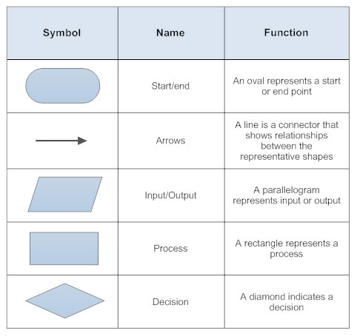

**1. Login Form**

Start

If Match With Users

Show Home Form

Read Data

Enter Email Id And Password

Incorrect Email Id or Password

**N**

**Y**

Stop

**2.User Registration Form**

Start

Invalid Data

Enter All Detail

Read Data

IF Data Valid

**N**

**Y**

Registration Successfully

Stop

**3.Forget Password**

Start

Invalid ANS

Enter Email Id

Security ANS

IF ANS is Valid

**N**

**Y**

Enter New Password

Password Successfully Change

Stop

**4.Download File**

Start

Material Not Available

Browse Category

View Files

IF File is Exist

**N**

**Y**

Download File

File Successfully Download

Stop

**Data Flow Diagram (DFD)**

A data flow diagram shows the way information flows through a process or system. It includes data inputs and outputs, data stores, and the various sub processes the data moves through. DFDs are built using standardized symbols and notation to describe various entities and their relationships.

Data flow diagrams visually represent systems and processes that would be hard to describe in a chunk of text. You can use these diagrams to map out an existing system and make it better or to plan out a new system for implementation. Visualizing each element makes it easy to identify inefficiencies and produce the best possible system.

A DFD model uses a very limited number of primitive symbols which are given below.

|  |  |  |
| --- | --- | --- |
| **Symbol** | **Name** | **Description** |
|  | Process | Show a process or action step. This is the most  common symbol in both process flowchart and process maps |
|  | Entity | An entity is the source or destination of data. The Source in a DFD represent these entities either provide data to the system or receive data from it. Entities are often represented as Rectangle. |
|  | Database | The most universally recognizable symbol for a data storage location this flowchart shape depicts a database. |
|  | Data Flow | Data flow is the movement of data between the entity, the process and the data store. |

**Context [0] Level DFD**

**Admin**

**User**

**User**

Download file

View category wise file

Enter Email and Password

New Account

New Registration

Login to Account

Enter Email and password

Login success

View Users

Delete user

View File

Delete file

View file

Material Sharing

**0.0**

User

Admin

Upload file

**Process [1] Level DFD**

1

Material hub

1.0

Login

Registration

Registration Successfully

Registration

Login into system

Login into system

Login Successfully

2.0

Login Successfully

Login

Upload File

View File

3.0

User

Admin

View File

Download File

File

Delete Account

Delete User

4.0

Logout from Site

Delete User

View User

|  |  |  |  |  |
| --- | --- | --- | --- | --- |
| Sr.No | Fields_Name | DataType | Constraint | Descrition |
| 1 | Id | int | Primary Key | Profile Id |
| 2 | Name | varchar(20) | - | Name of admin |
| 3 | Email Id | Varchar(30) | - | Email of admin |
| 4 | Password | varchar(10) | - | Password |
| 5 | Security Question | varchar(50) | - | Security Question |
| 6 | Security Answer | varchar(50) | - | Answer |

**1. Admin**

**2. Material**

|  |  |  |  |  |
| --- | --- | --- | --- | --- |
| Sr.No | Field_Name | DataType | Constraint | Description |
| 1 | Id | int | Primary Key | Id |
| 2 | Type | Varchar(15) | _ | Pdf |
| 3 | Name | varchar(50) | _ | Name of pdf |
| 4 | Date | varchar(50) | _ | Upload pdf |
| 5 | Uploadby | varchar(10) | _ |  |
| 6 | Dowanload | numeric(6,0) | _ |  |
| 7 | Path | varchar(50) | _ |  |
| 8 | Category | varchar(50) | _ |  |
| 9 | Image | varchar(50) | _ |  |
| 10 | Staus | bit |  |  |

**3. Profile**

|  |  |  |  |  |
| --- | --- | --- | --- | --- |
| Sr.No | Field_Name | DataType | Constraint | Description |
| 1 | id | Int | Primary Key | Id |
| 2 | Name | varchar(50) | _ |  |
| 3 | Email | varchar(30) | _ |  |
| 4 | Password | varchar(10) | _ |  |
| 5 | question | varchar(50) | _ |  |
| 6 | ans | varchar(50) | _ |  |
| 7 | status | Bit | _ |  |

**4. Request**

|  |  |  |  |  |
| --- | --- | --- | --- | --- |
| Sr.No | Field_Name | DataType | Constraint | Description |
| 1 | id | Numeric | Primary Key | Id |
| 2 | User Email | varchar(50) | _ |  |
| 3 | User Name | varchar(30) | _ |  |
| 4 | Subject | varchar(10) | _ |  |
| 5 | Message | varchar(50) | _ |  |

**Testing & Implementation**

Testing is a process of collection and error from system.

The main aim of the software testing process to determine all defect in our project.

The program was subjected to a set of test input and various observation were made and based on these observation it will be decided whether the program behaves as a expected or not.

Our project went through two levels of testing.

* + - Black-boxtesting
    - White-box testing

Black-box test are used to demonstrate that software function are operational that input is properly accepted and output is currently produced and the integrity of external information is maintained.

White-box tests are used to examine the procedural detail. It checks the logical path by test case. It can also check the condition, loops used in software coding. It checks that loops are working correctly on defined boundary value

**Black-box Testing**

Black-box testing focuses on the functional requirement of the software. That is black-box testing enable the software engineer to drive sets of input condition that will fully exercise all functional.

Requirement for the program black-box testing is not an alternative to white-box testing techniques.

Rather, it is a complimentary approach that likely to uncover different class of errors then whit-box methods.

We use in our coding to find errors in the following categories.

* + - Incorrect or missing functions
    - Interface errors
    - Errors in database
    - Initialization and termination errors
    - Performance errors

Feasibility Study

A feasibility study evaluates the project’s potential for success; therefore, perceived objectivity is an important factor in the credibility of the study for potential investors and lending institutions. There are five types of feasibility study—separate areas that a feasibility study examines, described below.

**1.Technical Feasibility -**this assessment focuses on the technical resources available to the organization. It helps organizations determine whether the technical resources meet capacity and whether the technical team is capable of converting the ideas into working systems. Technical feasibility also involves evaluation of the hardware, software, and other technology requirements of the proposed system. As an exaggerated example, an organization wouldn’t want to try to put Star Trek’s transporters in their building—currently, this project is not technically feasible.

**2. Economic Feasibility -**this assessment typically involves a cost/ benefits analysis of the project, helping organizations determine the viability, cost, and benefits associated with a project before financial resources are allocated. It also serves as an independent project assessment and enhances project credibility—helping decision makers determine the positive economic benefits to the organization that the proposed project will provide

**3.Operational Feasibility** - this assessment involves undertaking a study to analyse and determine whether—and how well—the organization’s needs can be met by completing the project. Operational feasibility studies also analyze how a project plan satisfies the requirements identified in the requirements analysis phase of system development.

**White-box Testing**

White-box testing is one of the major processes of system testing and it is a part of Black-box testing.

White-box testing check that code of system is depend on design or not if code is depend on design than system is correct otherwise there will be error.

White-box testing sometimes called glass-box testing.

Always we are thinking that there is no necessary to execute or check that the loops and conditions, And so large number of error is uncovered.

White-box testing method, we have checked that

* + - All independent paths within a function have been executed at least once.
    - All logical decision on their true or false side.
    - All loops working correctly at their boundary values and within their specified condition.

**Project Limitation**

* Only pdf file can uplode

**Bibliography**

|  |  |
| --- | --- |
| **Name** | **Description** |
| Book Reference | Professional Asp.net  Asp.net complete Reference |
| Web Site Reference | [www.google.com](http://www.google.com)  [www.codeproject.com](http://www.codeproject.com)  [www.csharpcorner.com](http://www.csharpcorner.com)  www.YouTube.com |